**BAHRIA UNIVERSITY (KARACHI CAMPUS**)

**Occupational Health and Safety (ENV - 101)**

**Assignment 01**

**Spring 2023**

**Class: BSE 2B Shift: Morning**

**Course Instructor: Ms. SADIQ TARIQ Due Date: 16 Apr 2023**

**Assignment Date: 30 Mar 2023 Marks: 05 Points**

**Student Name: ABDULLAH Registration #: 81962**



Question 01: Design a poster for an industry where people are working at height to educate them about the requirements which help them to prevent them from any injury or accident. **[CLO 5]**

Poster:

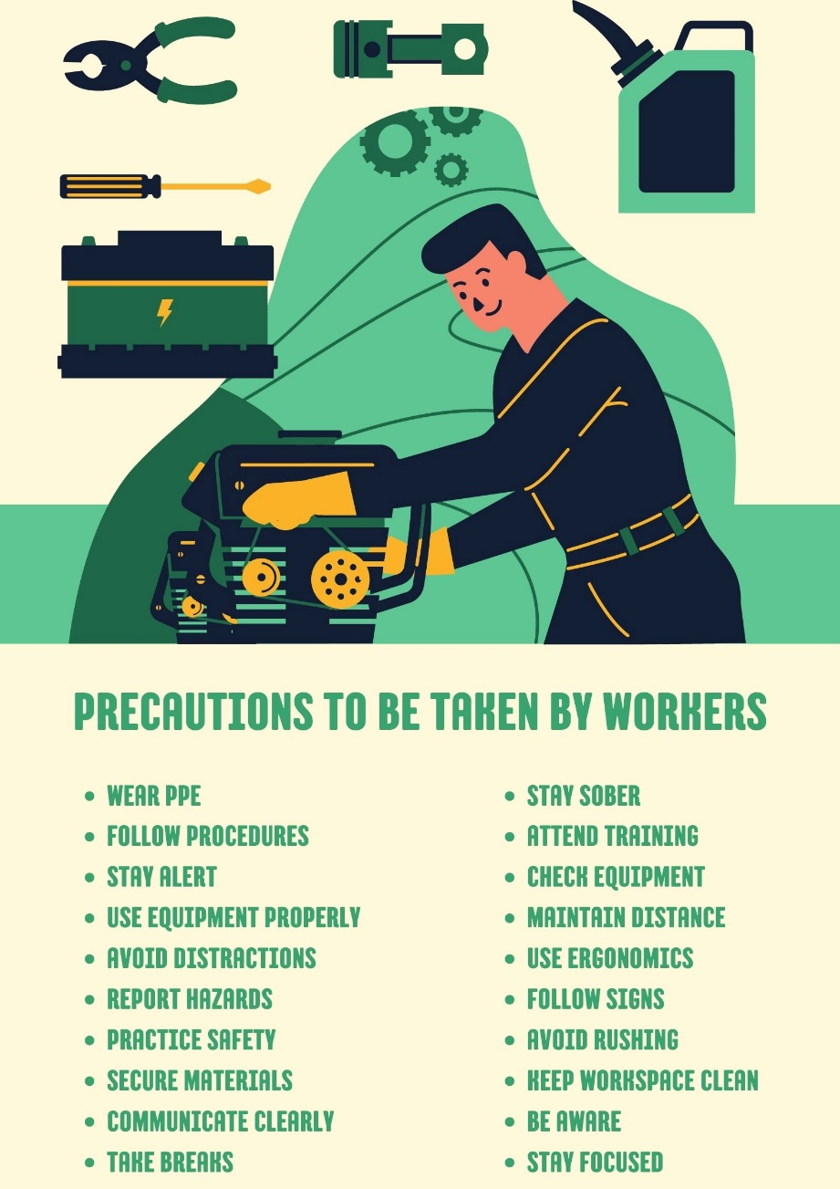

Question 02: Design a poster for an industry where people are working with hazardous chemicals to educate them about the requirements which help them to prevent them from any injury or accident. **[CLO 5]**

Poster:

